Wellbeing Impact Study of HS2 (WISH2) | Participant ID: <SPID>
Consent Form | Document ID: WISH2-WP2-W2-D2
Principal Investigators: Dr Robert Romanelli & Prof Stephen Morris  Organisations: RAND Europe & The University of Cambridge | IRAS ID: 302856  Human Research Ethics Reference: 22/EE/0292

Thank you for continuing to be involved in this research. Please read the Participant Information Sheet for WISH2 before completing this form.

We would like to offer you a £20 voucher as a thank you for completing this survey, or an equivalent donation to charity on your behalf. Once we receive your completed survey, we will send your voucher to your postal or email address. If your postal or email address has changed or is incorrect, please update your details in the table on the following page.

If there is anything you do not understand, or you have any questions, you can contact Dr Robert Romanelli (email: wish2@randeurope.org, phone: 01223 353329, post: RAND Europe, Eastbrook, Shaftesbury Rd, Cambridge, CB2 8BF, UK).

If you do not wish to continue to be part of this research or to be contacted again in future, please complete the refusal slip on the next page and return it using the pre-paid envelope. You can also refuse to participate by doing nothing, but if you do not send the slip back to us, we may contact you about this study again in the future.

If you do wish to take part, please read the statements below and if you agree sign and date the form. Please send this form and your completed survey back to us using the pre-paid envelope provided. If you would like a copy of the signed consent form to keep, please let us know using the contact details above.

If you prefer, you can complete this form and the survey online (see next page), or by telephone using the contact details above.

1. I have read and understood the Participant Information Sheet (version 1-2) for this study.
2. I have had time to think about the information, ask questions, and have had any questions answered well.
3. I understand my participation is voluntary and I am free to withdraw from this study at any time without giving any reason, and without affecting my medical care or legal rights.
4. I consent to completing the survey for this study, and to being invited to complete surveys for this study in the future by the WISH2 research team.
5. I understand that de-identified information collected about me (i.e. excluding my name and contact details) may be shared anonymously with other researchers to support future research. As with this project, I would not be identifiable in any published research findings.

 | [CONSENT BARCODE]
Name of participant (print)……………………………………………………………………………….......
Signature of participant……………………………………………. |  | Date……………………………….

Contact information:
We would like to contact you to update you about the findings from this study, send you a shopping voucher as a thank you, and potentially to invite you to take part in another survey in the future. Please let us know if any of the following details have changed:

 | Information | Corrections
Title | <TITLE>
First name | < FIRSTNAME>
Surname | < SURNAME>
Gender (M/F/Mx) | < GENDER>
Address | < ADD1> < ADD2>  < ADD3> < ADD4>
Postcode | < ADD5>
Mobile | < PHONE_MOBILE>
Email | < EMAIL>

REFUSAL SLIP
Only fill out this slip if you would like to withdraw from this and future waves of the WISH2 study

You can refuse to participate without completing this slip by not sending anything back to us at all. But this means we might contact you about the study again when we send out surveys in the future.

If you want to make sure we never contact you about the study again, send us this slip using the pre-paid envelope you received with this form.

I would like to withdraw from Wave 2 of the WISH2 study and not be contacted about it in future (please tick)

Your name (print)………………………………………… | [REFUSAL BARCODE]
Your signature…………………………………………… | [REFUSAL BARCODE]
Date…………………………….. | [REFUSAL BARCODE]

Wellbeing Impact Study of HS2: Wave 2 survey
The Wellbeing Impact Study of HS2 (WISH2) is an independent research project about how the High-Speed 2 railway (HS2) line may affect the mental health and wellbeing of people who live near the planned route. Despite the cancellation of Phase 2 of the route, we are still interested in hearing your views. You can find more about the project on our website: https://wish2.org/.
The survey has questions about your views of HS2, your health and wellbeing, your community and some other general questions about you. It should take 15-20 minutes to complete.

If you find any of the topics covered in this survey distressing, please contact your GP or one of the following support services:

- Samaritans: https://www.samaritans.org/how-we-can-help/contact-samaritan/talk-us-phone/
- Mind: https://www.mind.org.uk/information-support
- Citizens Advice: https://www.citizensadvice.org.uk

If you would prefer to complete the survey online, go to this website:
https://bit.ly/WISH2ConsentW2

You will need to enter your logon code:
< TOKEN>

START OF PAPER SURVEY

Ignore this if you are doing the survey online

Your views on the impact of HS2

High Speed Two (HS2) is a high-speed railway line linking London and Birmingham. It was originally intended to extend to other major cities in the Midlands and the North, but by October 2023 these additional phases had all been cancelled

This first section is about your familiarity with HS2 and its impacts on your life.

How closely have you been following the latest developments regarding HS2?

(Tick one)
[SURVEY BARCODE]
 | Very closely
 | Somewhat closely
 | Not very closely
 | Not at all

How close do you live to HS2 construction activity or its related impacts (such as road closures, loss of green space, temporary traffic lights, etc.)?
In November 2021, the eastern leg of Phase 2 towards Leeds was cancelled. In October 2023, the western leg towards Manchester was cancelled.
(Tick one)

I live right next to construction activity/impacts, I can see or hear it from where I live
I live close to construction activity/impacts, I can see or hear it near where I live
I live somewhat close to construction activity/impacts, I can see or hear it in areas surrounding where I live
I live close or somewhat close to construction activity/impacts, but I rarely or never see or hear it
I do not live close to construction activity/impacts
Other, please specify:

On balance, have the changes and cancellation of the HS2 Phase 2 route impacted your life today?

(Tick one)
Yes, and the impact has been positive
Yes, and the impact has been negative
No, it has not impacted me

Please provide any detail on this impact below.

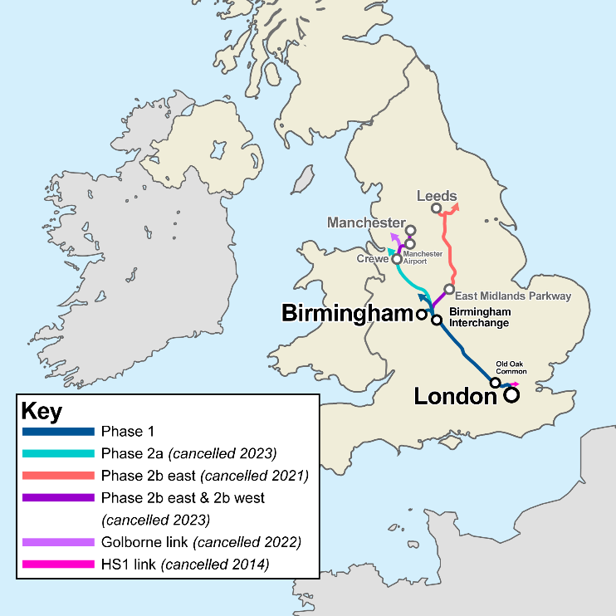

Adapted from image by User:Cnbrb, CC BY-SA 4.0, via Wikimedia Commons

What do you think about the decision to cancel Phase 2 of HS2?

(Tick one)
I support the decision
I neither support nor oppose the decision
I oppose the decision
I was not aware the decision had been taken

Q6: Since the cancellation was announced, have you noticed any changes in construction activity near where you live?
There have been announcements about alternative rail infrastructure projects, such as Northern Powerhouse Rail, with proposals to redirect HS2 funding, resources, and parts of the northern route to these projects.

(Tick one)
Yes, activity has reduced, and damage/disruption has been reversed
Yes, activity has reduced, but damage/disruption has remained (but could be reversed)
Yes, activity has reduced, but damage/disruption has remained and is irreversible
Yes, activity has intensified
No change – activity near me has stayed the same
No change – there was no activity near me anyway
I don’t know

Which of the following best reflects your view on central government’s role in delivering major infrastructure projects, such as HS2, in the future (independent of political party)?
(Tick one)
I fully trust the central government to deliver infrastructure projects
I partially trust the central government to deliver infrastructure projects
I partially distrust the central government to deliver infrastructure projects
I fully distrust the central government to deliver infrastructure projects
Don’t know

Overall, what do you think about the announcement of these potential alternative rail projects?
(Tick one)
Very positive
Somewhat positive
Neutral
Somewhat negative
Very negative
I don’t know, I haven’t heard about other projects

Which of the following things about HS2 Phase 2 will potentially have an impact on you in the next 1 to 2 years?

(Please tick one column per row)
 | Very positive impact | Somewhat positive impact | Neutral or no impact | Somewhat negative impact | Very negative impact | Don’t know

Local environment (e.g. access to parks, walking trails, visual appeal)

Noise pollution (e.g. traffic or construction noise)

Air pollution (e.g. dust from construction)

Light pollution (e.g. temporary construction lighting, flood lighting)

Traffic/travel times for commuting journeys (work or school)

Traffic/travel times for non-commuting journeys

Cost of public transport

Employment

Local businesses

House prices

Community networks and social circles

Ability to access local services (e.g. healthcare, social care/support, sports/leisure or cultural facilities)

Ability to plan for the future (e.g. decisions about moving, changing jobs, or other long-term plans)

Anything else? Please specify:

________________________________

________________________________

Your health and wellbeing

This section is about your health and wellbeing, and your ability to do day-to-day activities. These questions may be sensitive for some people; we want to highlight that there is no right or wrong answer.

Which, if any, of the following long-term conditions do you have?

(Tick all that apply)
A heart condition, such as angina or atrial fibrillation
Arthritis or ongoing problem with back or joints
Autism or autism spectrum condition
Blindness or partial sight
A breathing condition such as asthma or COPD
Cancer (diagnosis or treatment in the last 5 years)
Deafness or hearing loss
Diabetes
Alzheimer’s disease or other cause of dementia
High blood pressure
Kidney or liver disease
A learning disability
A mental health condition
A neurological condition, such as epilepsy
A stroke (which affects your day-to-day life)
Another long-term condition or disability
I do not have any long-term conditions

Over the last 2 weeks, how many days have you had trouble falling asleep or staying asleep or sleeping too much?

(Please choose a number between 0 and 14)

Please indicate which statements best describe your own health state today: Mobility

(Tick only one)
I have no problems in walking about
I have some problems in walking about
I am confined to bed

Please indicate which statements best describe your own health state today: Self-care

(Tick only one)
I have no problems with self-care
I have some problems washing or dressing myself
I am unable to wash or dress myself

Please indicate which statements best describe your own health state today: Usual activities (e.g. work, study, housework, family or leisure activities)

(Tick only one)
I have no problems with performing my usual activities
I have some problems with performing my usual activities
I am unable to perform my usual activities

Please indicate which statements best describe your own health state today: Pain or discomfort

(Tick only one)
I have no pain or discomfort
I have moderate pain or discomfort
I have extreme pain or discomfort

Please indicate which statements best describe your own health state today: Anxiety or depression

(Tick only one)
I am not anxious or depressed
I am moderately anxious or depressed
I am extremely anxious or depressed

In the last 12 months, have you been prescribed anti-depressants?

(Tick only one)
Yes
No
Unsure

Below are some statements about feelings and thoughts. Please tick the box that best describes your experience of each over the last 2 weeks.
(Please tick one box for each row).
 | None of the time | Rarely | Some of the time | Often | All of the time

I’ve been feeling optimistic about the future

I’ve been feeling useful

I’ve been feeling relaxed

I’ve been feeling interested in other people

I’ve had energy to spare

I’ve been dealing with problems well

I’ve been thinking clearly

I’ve been feeling good about myself

I’ve been feeling close to other people

I’ve been feeling confident

I’ve been able to make up my own mind about things

I’ve been feeling loved

I’ve been interested in new things

I’ve been feeling cheerful

Your healthcare use

This section is about your use of healthcare services.

In the last 12 months, how many times have you talked to, or visited a GP or family doctor about your own mental health?

(Tick one; do not count any visits to a hospital)
No visits
One or two
Three or more
Don’t know

In the last 12 months, how many times have you attended a hospital or clinic (e.g. as an out-patient or day patient) for a mental health problem?

(Tick one)
No visits
One or two
Three or more
Don’t know

Your residence and community

This next set of questions ask about how you feel about the place where you live.

Does your household own your accommodation outright, is it being bought with a mortgage, is it rented or does it come rent-free?

(Tick only one)
Owned outright
Owned/being bought on mortgage
Shared ownership (part-owned part-rented)
Rented
Rent free
Other

Does your accommodation experience any pollution, grime or other environmental problems caused by traffic or industry?

(Tick only one)
Yes
No

The next two sets of questions focus on opportunities in your local area. Q23 asks for your views on the opportunities available to people in your local area generally. Q24 asks about what you specifically think about the quality of those opportunities.

This question asks about the range of opportunities for people in your local area. What do you think about the general availability of the following... (Please tick one box for each row)
 | There are plenty of opportunities | There are good opportunities | Mixed | Opportunities are quite limited | Opportunities are extremely restricted

Community groups, clubs or organisations in your local area

Opportunities to undertake voluntary participation in your local area

Opportunities to undertake leisure opportunities (e.g. sports and entertainment) in your local area

Opportunities to access suitable housing in your local area

Opportunities to find suitable work in your local area

Opportunities to secure additional income in your local area

Educational opportunities in your local area

Opportunities to improve your health in your local area

Opportunities to contact your family in your local area

Opportunities to meet people in your local area

This question is about the quality of the opportunities available to you locally. How do you feel about... (Please tick one box for each row)
 | Terrible | Displeased | Mostly dissatisfied | Mixed | Mostly satisfied | Pleased | Delighted

Opportunities to be involved with community groups, clubs or organisations available in your local area

Opportunities for voluntary participation available in your local area

Opportunities for leisure activities available in your local area

Opportunities for accommodation available in your local area

Opportunities for education available in your local area

Opportunities to improve your health available in your local area

The extent to which you are included in society

The opportunities you have to contact your family

Opportunities for making new friends in your local area

Opportunities to meet people in your local area

The environment in your local area (access to parks, walking trails, visual appeal etc.)

Opportunities for people to find suitable work in your local area

General questions about you

These questions are about your employment and how you travel

Which of these is currently most applicable to you?

(Tick only one)
Self-employed
In paid employment (full-time or part-time)
On a government training scheme
Retired from paid work altogether
On maternity leave
Unemployed
Full time student/at school
Long term sick leave or unable to work for health-related reasons
Looking after family or home
Something else:

How do you usually travel to work or for education purposes?

(Tick only one; if you work from home on some days, answer for the days you travel to your workplace)
Underground, metro, light rail, tram
Train
Public bus, minibus or coach
School or local authority bus, minibus or coach
Motorcycle, scooter or moped
Car or van
Taxi/minicab
Bicycle
On foot
There is no travel involved
Not working or in education
Other (specify):

Do you look after, or give any help or support to, family members, friends, neighbours or others because of either: long-term physical or mental ill health /disability or problems related to old age?
(Tick one; do not count anything you do as part of paid work)
No
Yes, 1 to 9 hours a week
Yes, 10 to 19 hours a week
Yes, 20 to 34 hours a week
Yes, 35 to 49 hours a week
Yes, 50 or more hours a week

How do you usually travel when you are helping or supporting others?

(Tick the most used one; include travel with people you help)
Underground, metro, light rail, tram
Train
Public bus, minibus or coach
School or local authority bus, minibus or coach
Motorcycle, scooter or moped
Car or van
Taxi/minicab
Bicycle
On foot
There is no travel involved
Not applicable to me
Other (specify):

Would you be interested in taking part in an interview to discuss the impacts of HS2 in further detail with the research team? We will discuss this survey and give you a chance to provide further detail. We will compensate you for your time with a £30 voucher.
Yes
No

Would you prefer to receive a £20 Select Shopping Voucher or for us to donate £20 to charity on your behalf?

 | Voucher
 | OR
Charity donation to:
(Tick only one)
 |  | Mind supports millions of people every year through our helpline, information services and online communities. Mind also have a network of local Minds providing face-to-face services tailored to communities across England and Wales.
 | 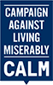 | The Campaign Against Living Miserably (CALM) is a national charity dedicated to preventing male suicide by helping men who are down or in crisis, promoting culture change so that any man considering suicide feels able to seek help and campaigning for better understanding of suicide and prevention.
 |  | YoungMinds is the UK's leading charity championing the wellbeing and mental health of children and young people. Driven by their experience, YoungMinds creates change so that children and young people can cope with life's adversities, find help when needed, and succeed in life.
 |  | Place2Be provides in-school support to improve the emotional wellbeing of pupils, families and school staff, and expert training for professionals working with children. The charity helps children cope with emotional challenges so they can have brighter futures.

THANK-YOU FOR COMPLETING THIS SURVEY

PLEASE PUT THIS SURVEY BOOKLET INTO THE REPLY-PAID ENVELOPE THAT CAME WITH THIS SURVEY AND POST IT BACK TO US

If you found any of the topics covered in this survey distressing, please contact your GP or one of the following support services:

- Samaritans: https://www.samaritans.org/how-we-can-help/contact-samaritan/talk-us-phone/
- Mind: https://www.mind.org.uk/information-support
- Citizens Advice: https://www.citizensadvice.org.uk

THIS PAGE IS INTENTIONALLY LEFT BLANK

